GIS is a computer system that analyzes and displays geographically referenced information.

REMOTE SENSING process of acquiring information about an object, area, or phenomenon from a distance, typically using satellite or aerial sensor technologies.

VECTOR DATA is composed of cells in a matrix.

RASTAR DATA is composed of cells in a matrix

CREATING OF AN ACCOUNT IN THE USGS EARTH EXPLORER.

Clicking on the login button you will be directed to a sign in or create a new account.Input the information which are required and click create an account.After the account is successfully created you will see on the top right of the page your name.

DOWNLOADING OF THE LANDSATE IMAGE 8 OF KIAMBU COUNTY FROM USGS EARTH EXPLORER.

After creating an account I used the coordinates of Kiambu county and changed them to degrees, minutes and second so as to input to the latitudes and longitudes. The following were the coordinates and later changed to degrees, minutes and seconds 1.0314 N to 1 degree 1 minute and 53 secondSOUTH, 36.8681 EAST to 36 degrees 52 minutes and 6 seconds.

Input the data required such as cloud cover from 0-10 , date of 2022 , landsate 8 and click on results to see which images you get.On the images download an image which has the lowest cloud cover then download. Here is a meta data of our image downloaded.

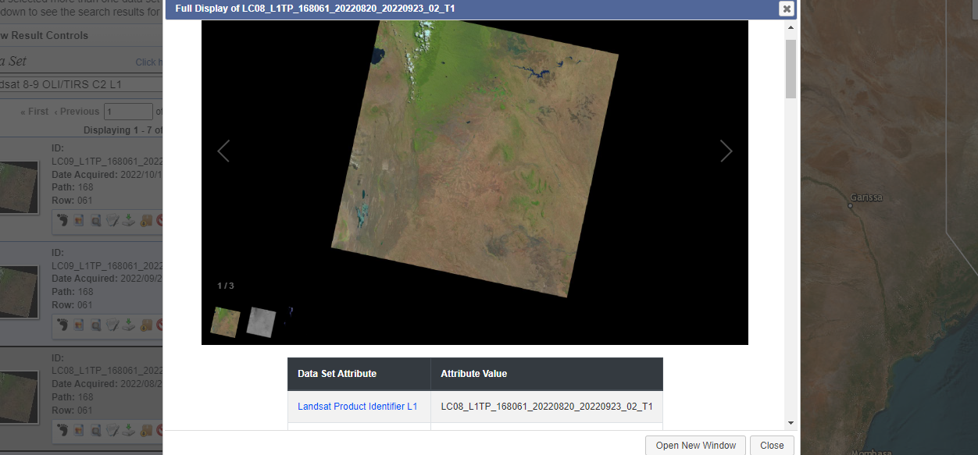

CLIPPING AND MASKING

Clipped the Kiambu county from the kenya counties and finally did a masking of the image by extracting by masking of the image by clicking on the arc toolbox ,spatial analytics tool then extract by masking, input the required inputs then click ok on the table.

After masking uncheck the kenya counties and also the first downloaded image which you will check out the extract_tiff 1 and also the Kiambu county clipped.Here is the final image and output.

